C:\Users\Siva\AppData\Local\Microsoft\Windows\INetCache\Content.Word\zenith 1138.png

**How to Install**

**Tomcat Server**

**Document:**

**Issued on : 26-April-2016**

**Author : Vinod**

**Version : 1.0**

**Copyright**

ã 2015 Zenith Services Inc.

All rights reserved

The recipient receives this document on the condition that the recipient will keep the document confidential and will not use its contents in any form or by any means without the prior written permission of Zenith Services Inc. Moreover, the recipient is not authorised to place this document at the disposal of any third party without the prior written permission of Zenith Services Inc.

If such permission is granted, it will be subject to the condition that the recipient ensures that any recipient of this document, or information contained therein, is held responsible to Zenith Services Inc. for the confidentiality of that information.

Zenith Services Inc. undertakes to treat all information provided by the recipient as confidential.

The General Terms of Zenith Services Inc. apply to this document.

All trademarks used in this document remain the property of their rightful owners.

Apache Installation Process

1. Follow the Link to Download Tomcat Server download to your Computer.

**https://tomcat.apache.org/download-60.cgi**

Go to Binary Distributions and choose 32-bit/64-bit Windows Service Installer (pgp, md5, sha1)

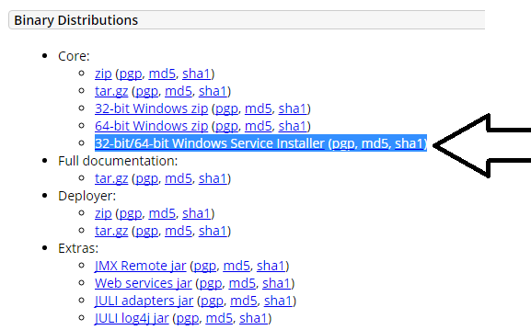

Click the above arrow button Tomcat Server automatically Download.

Double click the Download file it will be open like this

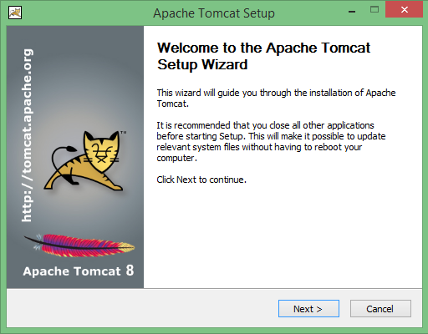

Click on Next button to proceed the installation process.

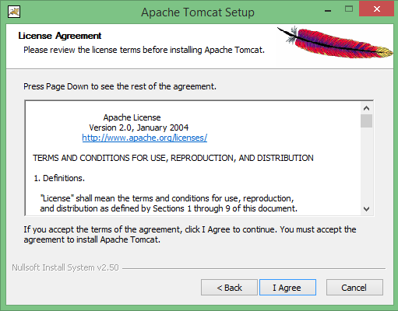

Click on I Agree button to proceed the installation process.

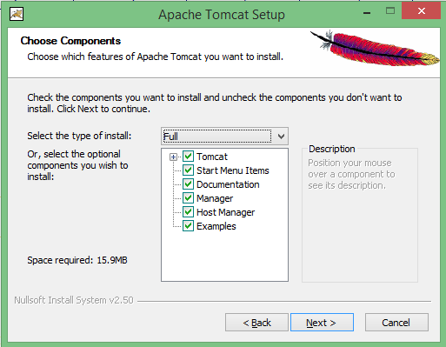

Change Normal to Full in drop Down box button Select all components andx click Next button to continue.

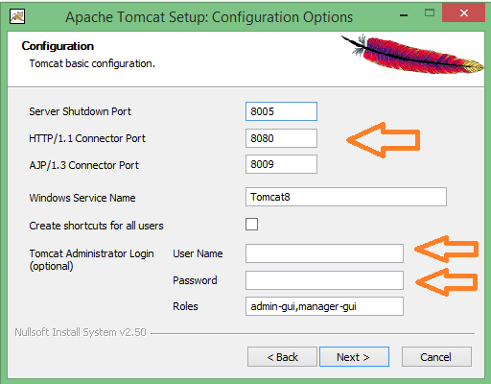

Now choose the port number on which you want to run the tomcat server. **HTTP/1.1 Connector Port** Number 8080 as its default value. And I gave **User Name** : admin and **Password** : admin Now click on the Next button.

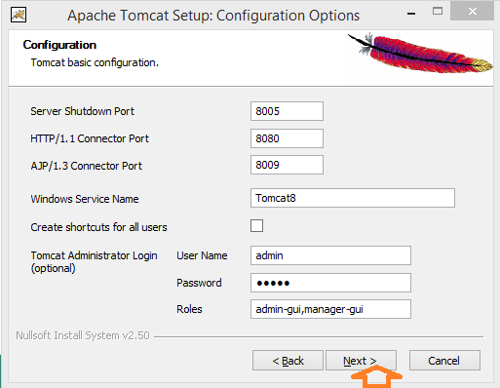

Please select the JRE path..

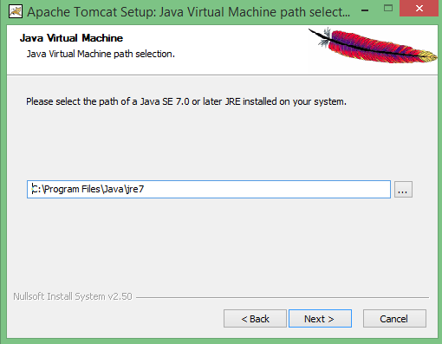

Click on Next button to proceed the installation process.

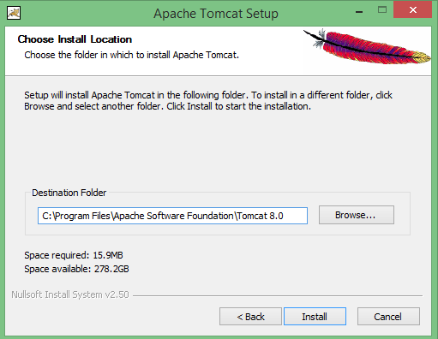

Click Browse Button and where to install Tomcat server choose Right path and click on Install button is getting installed.

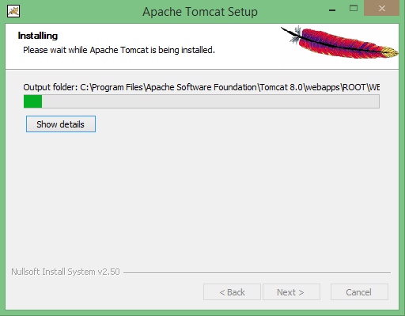

After completion of installation click on Finish.

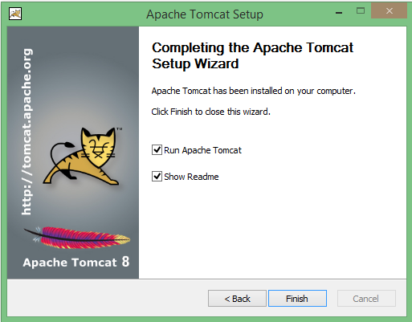

After successfully installing, a shortcut icon to start the tomcat server appears in the icon tray of the task bar.

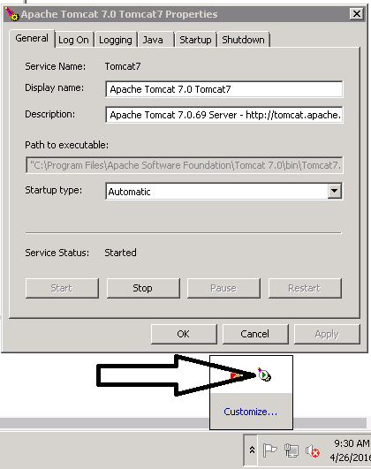

Go to My Computer -Right click on mouse.

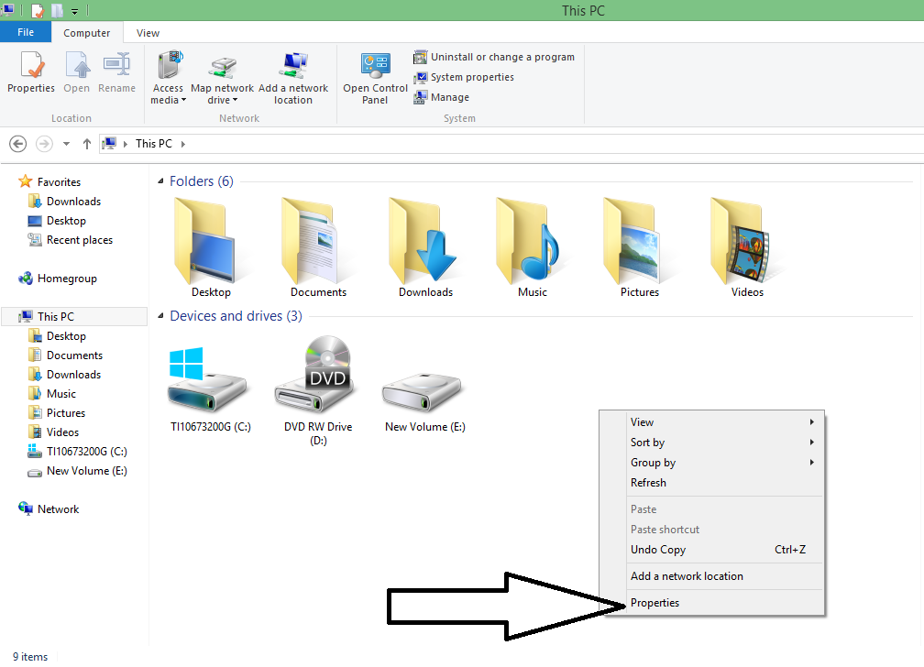

Click Properties.

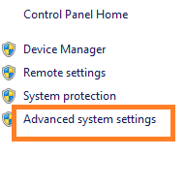  
Click On Advanced system settings.

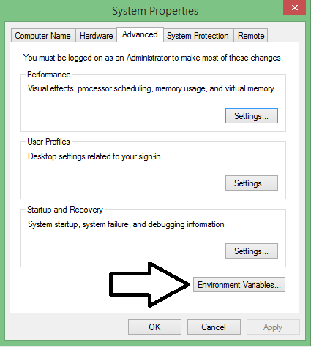

Click Environment Variables Button

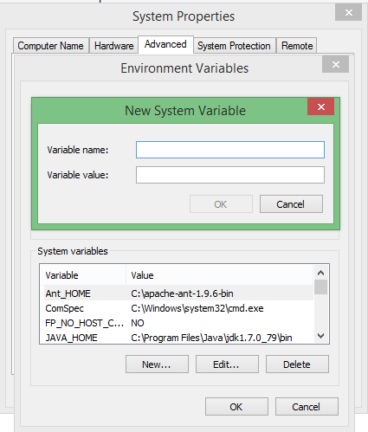

Go to System variables ----> Click New

Please check JAVA_HOME Give the Values

Variable name**: JAVA_HOME**

Variable value: C**:\Program Files\Java\jdk1.7.0_79\bin**

Click Ok Button.

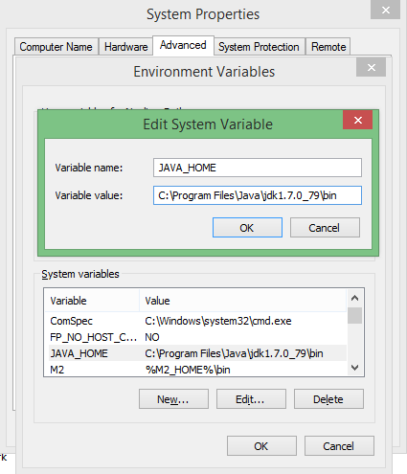

Give the Values

Variable name: CATALINA_HOME

Variable value: C:\Program Files\Apache Software Foundation\Tomcat 7.0

Click Ok Button.

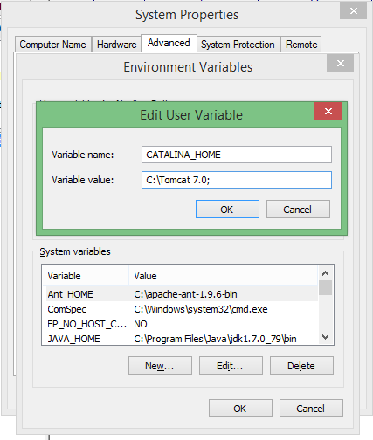

Click Ok

Go to this path

C:\Program Files\Apache Software Foundation\Tomcat 7.0\bin\

See the bin folder like this

Run the Tomcat 7.0

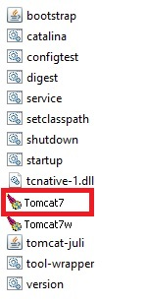

It will be open Command prompt

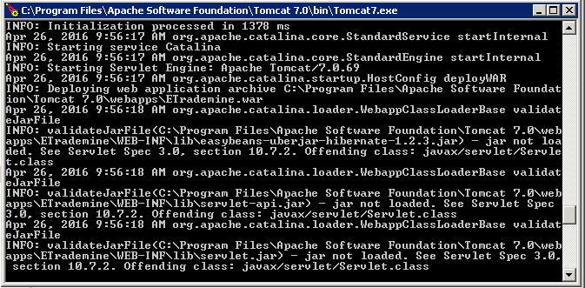

we have open a new browser and give **http://localhost:8080/** .Then this page will appears to confirm that it is installed.

